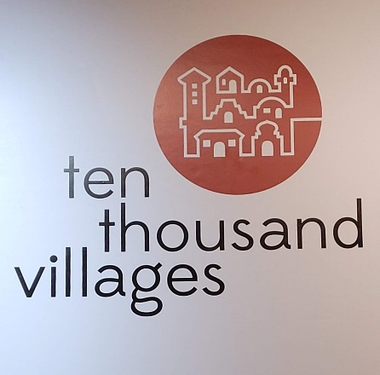 | DKG  Purposeful Seminar  June 20 & 21, 2023  REGISTRATION FORM | 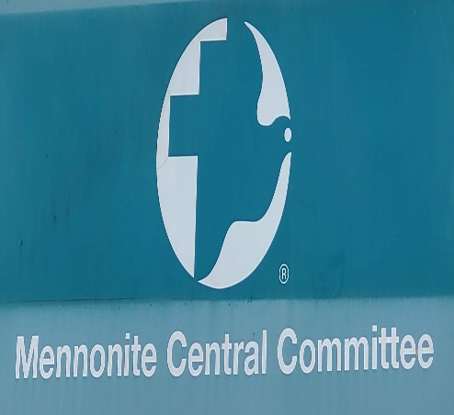

Name: _____________________________________________ Chapter: ___________________________
Address: ______________________________________________________________________________
City/State/Zip:__________________________________________________________________________
Cell Phone Number: ______________________________________________________________
Email Address: __________________________________________________________________________
Purposeful Seminar Schedule
June 20, 2023 June 21, 2023
Orientation 7:00 pm to 8:45 pm Continental Breakfast at the Wyndham 7:30 to 8:30 am
Hopewell Room Board Bus: 8:45 am
Ten Thousand Villages & Kitchen Kettle Village
Lunch on your own
Board Bus: 11:45 am
Mennonite Central Committee
Board Bus for Wyndham: 3:00 pm
Participation is limited to 50 members.
Purposeful Seminar fee: $50

Registration Form deadline for Purposeful Seminar is May 17, 2023.
Checks should be made payable to : Delta Kappa Gamma
Mail completed form and check to: Purposeful Seminar Treasurer 524 East Watson Street Bedford, PA 15522

