ΔΚΓ DK GRAM
Omicron Chapter
May 2019 Editor Michelle Hopkins

Our Mission: The Delta Kappa Gamma Society International promotes professional and personal growth of women educators and excellence in education.

Our Vision: Leading Women Educators Impacting Education Worldwide

MEETING: Tuesday, May 14, 2019 at 5:30 p.m.
The Villa
2016 East Third Street
Williamsport, PA 17701

Respond to Deb Leonard at catluvr53@aol.com by Tuesday, May 8 to confirm if you will attend because we need to give a count to the Villa.

https://www.zmenu.com/the-villa-williamsport-online-menu/

OUR PROGRAM FOR THE EVENING

We will hold a Chinese auction for World Fellowship and pass out copies of the book Where Did I Leave My Glasses by Martha Wineman Lear. This book will be our meeting (book discussion led by Jackie Thomas) in September. Jackie is providing copies for each member. Thank you Jackie.
Please bring items for the Chinese auction. Think of what your fellow chapter members would like to bid on. Assuredly you will use your imagination and we will raise a nice sum for World Fellowship. Thank you in advance for your generosity.
Also, remember that dues need to be paid at the May meeting. You can make out your check to Omicron Chapter and the total amount is $77.00.

In case you missed our March meeting:
Guest speaker for the evening was Dawn Linn, the Chief Executive Director of the YWCA, where she directs a variety of programs. Dawn educated us about the Wise Options for Women program and the scope of scope of domestic violence. Chapter members donated personal care items to be given to the program. A big thank you to Joy Walls for arranging this worthwhile presentation and to Dawn Linn for making us realize the importance of this program. Dawn was so appreciative for all our donations as evidenced in her thank you note to our chapter: “Every day we strive to help the most vulnerable rise above the difficult circumstances of their lives. But, we cannot do it alone. It is individuals and groups, such as you, that continue to help us strengthen our programming. Thank you for continuing to believe in our passion. You are a wonderful group of women sharing your philanthropic leadership. I enjoyed getting to know you. And, it came with a lovely dinner. Thank you. Warmest regards, Dawn”

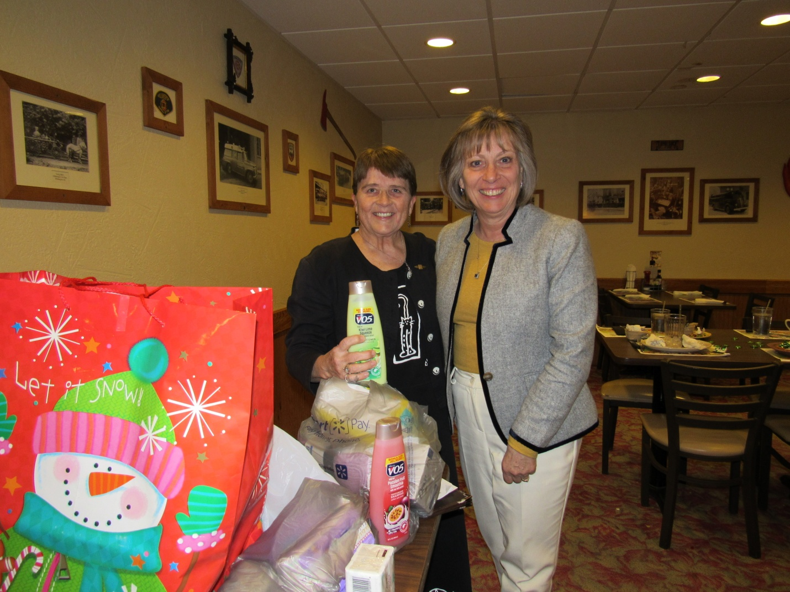

Inside our Chapter:

Jackie Thomas “got into the gallery!!!!! And, I'm pleased. I am also packing right now to go to the PA DKG Creative Arts Retreat where I'll be teaching two workshops - one to make a twined mandals (basket making) and the second a printing on wearables workshop. I'm looking forward to the week-end in Ludlow.”

This is part of the letter to Jackie regarding her acceptance: “The Arts & Humanities Jury of The Delta Kappa Gamma Society International is pleased to announce the publication of your basketry entry entitled Facing Infinity, and your sculpture entitled Navajo Dibe Mask in the DKG Gallery of Fine Arts, an online gallery of works of art and letters at www.dkg.org. We anticipate the unveiling of the new Gallery works on May 1, 2019. There will be an article in the DKG News publicizing the new works in the Gallery. Your work will stay up in the Gallery for six months, after which it will be archived.” So next month be sure to visit the website and check out Jackie’s entries. Congratulations!

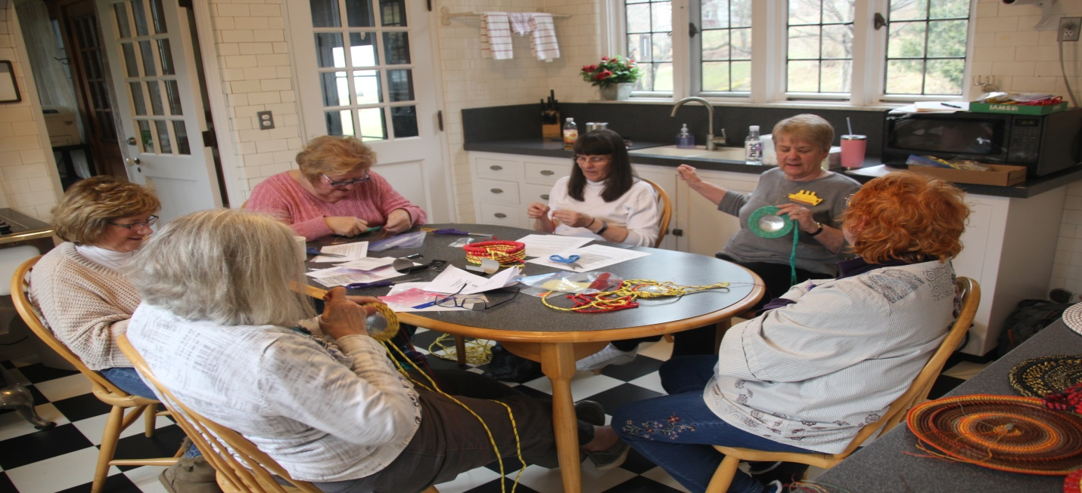
Jackie Thomas and participants at the DKG PA Creative Arts Retreat.

A bit of news that has Eleanor Kodish excited! “I am planning on attending my 76th high school reunion on June 1. I graduated in 1943 in a class of 24 from Rush High School (now Elk Lake School District in Susquehanna County. ) The reunion is for anybody who ever graduated from Rush High School, not just the class of ‘43. Another member, Ray Hollister, and I are the only ones left in our class. I just talked to him on the phone this week, and he, like your’s truly, is in good health. Then, the following weekend I am planning on attending my 72nd college reunion, class of ‘47, at Mansfield University. My roommate, who lives in Victor, NY, is hoping that she will be able to attend, also. I am still taking PT for my arm and Carpal Tunnel surgery, but recovering nicely!
Dr. Sherry Griggs retired at the end of March from her position as superintendent of the Sayre Area School District. Sherry dedicated 35 years to public education. She and her husband Joe are looking forward to traveling in the coming months. Her new email address is segriggs54@comcast.net. Congratulations Sherry for all your accomplishments and contributions to this career that we all have made such an integral part of our lives.

And so much for retirement. Michelle Hopkins has been subbing many weeks now for a Montoursville Area H.S. teacher out on medical leave. Michelle has received permission from PSERS to finish the school year. Once a Warrior…

From Christine Kindon: “Our youngest child, Joe (32), and his wife Asha, both special education teachers for the Chester County IU, celebrated the birth of their first baby on March 22. Her name is Adlee Elizabeth Kindon, and she is a beauty! The entire family has been ecstatic to welcome her to our world.”

2019 PA State Convention Saturday, June 14 - 16, 2019

If you have not given your 2019 PA State Convention form to Tammy Morgan and may still be thinking of attending, you must send your form to Tammy by May 1. State Convention registration forms are in the Spring 2019 issue of The Keystonian.

Happy Spring!

