Pi Publisher

DELTA KAPPA GAMMA
Summer 2019

Dear Pi Sisters,

Here is a reminder of upcoming opportunities for you to be a part of DKG locally and beyond…

- June 14-16, 2019 - Pennsylvania State Convention, Nittany Lion Inn, State College, PA

- June 26, 2019 Pi Chapter Meeting at the home of Greta Marie Taft. Meeting and dish to pass luncheon (more information to follow)

- July 30-August 1, 2019 International Conference, Mashantucket, CT

- August 6th or 8th 2019 Gate Keepers at the Tioga County Fair, Whitneyville, PA

- August 10, 2019 Annual Scholarship Chicken BBQ, Mansfield, PA

- August 17, 2019 Boating and Craft Show, Hammondsport, NY
Creative Arts Retreat 2019
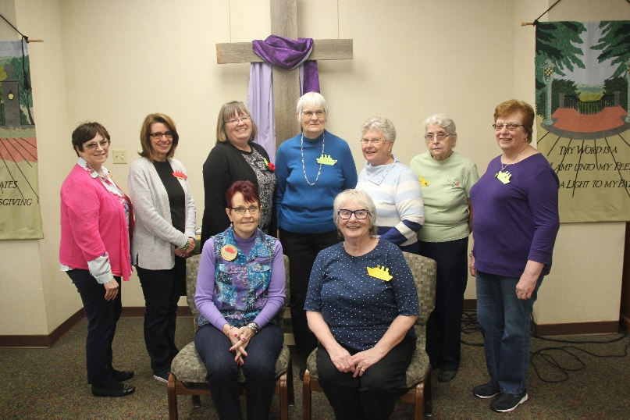
Eight Pi Chapter members and one guest attended the retreat in Ludlow, PA. Several members also were workshop presenters. Kathy Cummings, Watercolor; Vonda Reed, Goddess Bracelets. Kay Stuart had a part in a skit preformed during the talent show and provided comic relief with a cute skit. We had two members attend for the first time.

During the April meeting held in Westfield, we held a Memorial Service for member Judi Castano. The Bi annual Chinese Auction made $140.00 with the money going to the general fund.

Information about the June 26th meeting will be sent out 2 weeks prior to the meeting.

Please contact Kay Stuart if you are interested in attending the State Convention so carpooling can be arranged.

